Dear All,

Greetings !

This is Arulalan Thanigachalam from India.

I have created 103 new markers in CDAT [ Climate Data Analysis Tools ].

I created these markers for to plot the “Weather Symbols” over CDAT World Map or Continents.

I had set the golas to create new markers in CDAT for the following 100 weather symbols.

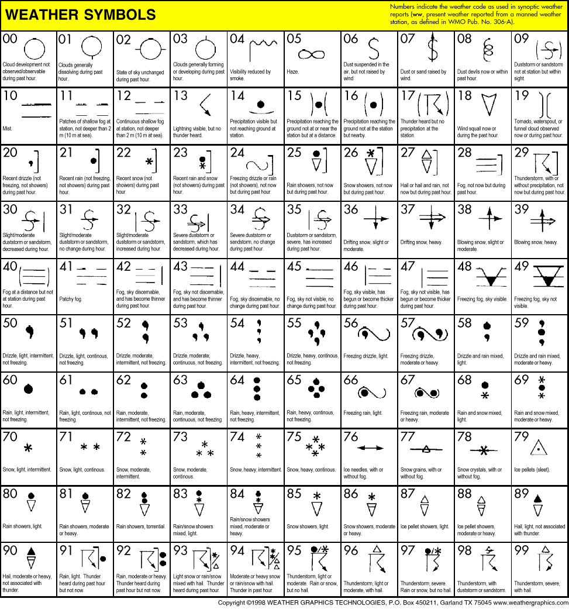

Yes, I done all the above symbols as like CDAT markers.

I got the help from Mr.Charles Doutriaux , Developer of CDAT how to create new markers in source of CDAT and how to compile into the pre installed cdat location itself.

I am thanking him.

By this help, I studied and understood the exisiting markers algorithms and its source code in “C”.

ya, all the markers are writting in “C” language itself.

My New Markers Outputs :

From w00 to w29 weather symbols in markers

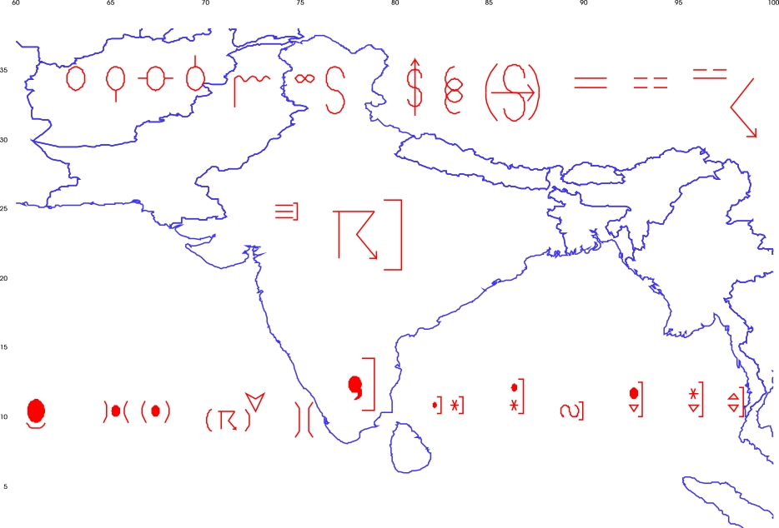

From w30 to w59 weather symbols in markers

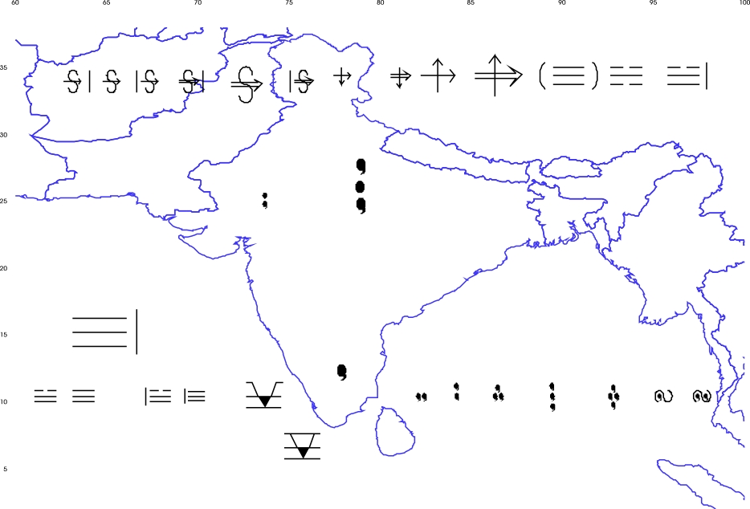
From w60 to w89 weather symbols in markers

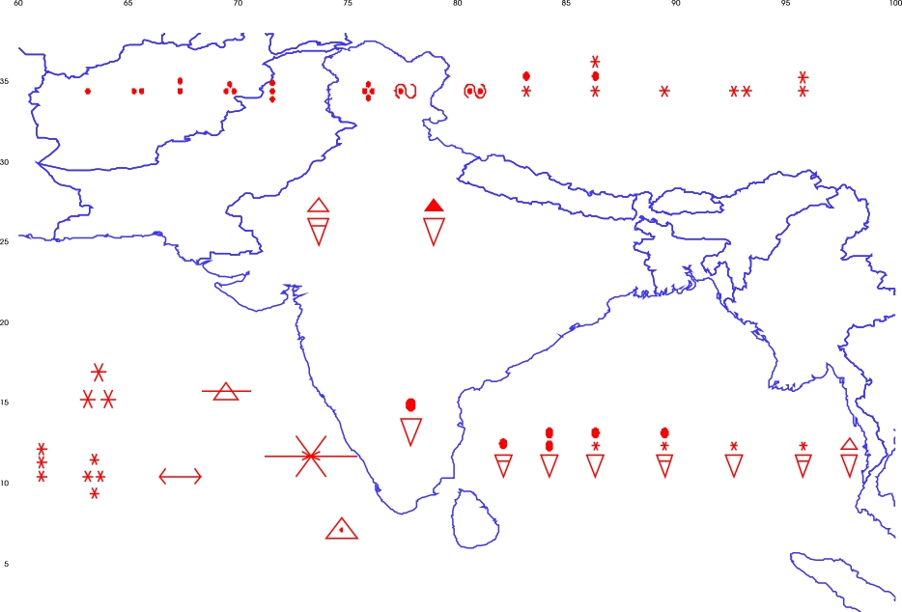
From w90 to w99 and w200, w201, w202 weather symbols in markers
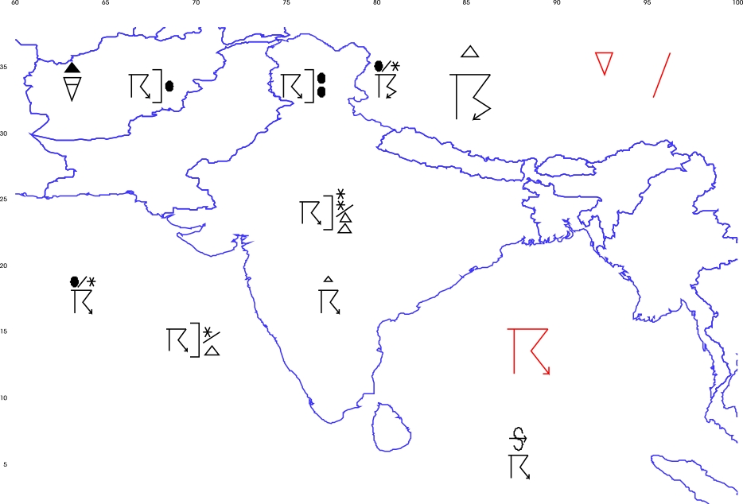

In the above last output, you can see 3 red colored markers.

These 3 symbols are not showned in my goals image.

We can call this extra markers by just calling CDAT python program as like below.

Markers.type= ['w200', 'w201', 'w202'] 0r [200,201,202].

You can call all the 100 weather symbols markers by either

type = [00, 01, 02, 03, . . . , 97, 98, 99] or type = ['w00', 'w01', 'w02', 'w03', . . . , 'w97', 'w98', 'w99']

Thanks to CDAT team.

My Mail Id : arulalant@gmail.com

My Blog : http://tuxcoder.wordpress.com

http://tuxworld.wordpress.com

I am very happy to say that, this is my simple contribution to CDAT and Open Source World.

